

**Tribhuvan University**

**Faculty of Humanities and Social Science**

**THALI**

**A PROJECT REPORT**

On

**Submitted to**

**Department of Computer Application**

**Chitwan College of Technology**

Bharatpur-10, Chitwan

2023

***In partial fulfillment of the requirements for the Bachelors in Computer Application***

**Submitted by**

Siddhartha Dwivedi(6-2-1133-66-2020)

Seema Bhattarai(6-2-1133-65-2020)

**July, 2023**

**Under the Supervision of**

**Ram Binay Gupta**

**Tribhuvan University**

**Faculty of Humanities and Social Science**

**Supervisor’s Recommendation**

I hereby recommend that this project prepared under my supervision by **SIDDHARTHA DWIVEDI and SEEMA BHATTARAI** entitled **“THALI.COM”** in partial fulfillment of the requirements for the degree of Bachelor of Computer Application is recommended for the final evaluation.

..............................

**SIGNATURE**

Mr. Ram Gupta

**SUPERVISOR**

Lecturer

Department of Computer Application

Chitwan College of Technology

Bharatpur-10, Chitwa

**LETTER OF APPROVAL**

This is to certify that this project prepared by **SIDDHARTHA DWIVEDI and SEEMA BHATTARAI** entitled “**THALI.COM”** in partial fulfilment of the requirements for the degree of Bachelor in Computer Application has been evaluated. In our opinion it is satisfactory in the scope and quality as a project for the required degree.

|  |  |
| --- | --- |
| **...........................................................**  **SIGNATURE of Supervisor**  Ram Binay Gupta  Bharatpur-10, Chitwan | **...........................................................**  **SIGNATURE of HOD/ Coordinator**  Department of Computer Application |
| **...........................................................**  **SIGNATURE of Internal Examiner Internal Examiner** | **...........................................................**  **SIGNATURE of External Examiner External Examiner** |

**ABSTRACT**

"Thali.com: Revolutionizing Food Delivery through Automation.

Thali.com is an innovative online food ordering and delivery platform that aims to transform the food delivery industry by providing a seamless and efficient experience for customers, restaurants, Delivery persons, and administrators. The traditional manual systems used by many food delivery services can be slow and error-prone, leading to suboptimal customer experiences. Thali.com seeks to address these challenges by leveraging advanced automation to streamline the order fulfillment process.

At Thali.com, customers will enjoy a user-friendly interface that allows them to easily explore menus from a diverse range of nearby restaurants, place orders, and conveniently make online payments. The orders are automatically transmitted to the restaurant's dashboard, facilitating food preparation and enabling restaurants to efficiently manage and process incoming orders. Delivery persons, thoughtfully assigned by the Thali.com system, receive timely notifications through their mobile app, empowering them to promptly pick up and deliver orders to customers.

Thali.com equips administrators with robust tools for managing orders, tracking Delivery persons, and closely monitoring customer feedback. By harnessing the power of automation, Thali.com aims to establish a dependable and efficient food delivery service that is intuitive, empowering, and highly effective. The platform aspires to elevate the food delivery experience for all stakeholders, setting new standards in the industry and revolutionizing the way food is delivered to customers.

**ACKNOWLEDGMENT**

The success of this project would not have been possible without the kind support and assistance of our teachers and project group, and we are immensely blessed to have got this all along the duration of our project. We would like to extend our profound gratitude to every one of them.

We are highly indebted to **Chitwan College of Technology** for constant guidance and supervision, as well as for providing all the necessary ICT infrastructure and friendly environment for the successful completion of the project. We are also appreciative of the efforts of our Project Head **Mr. Ram Binay Gupta**, without his supporting role, the project would have been nowhere near completion.

I would like to express our special thanks of gratitude to our supervisor **Mr. Ram Binay Gupta,** for giving us support throughout the course and thus made us capable of being worthy of recognition and extended every facility to us for making and completing this project smoothly.

Similarly, our thanks and appreciations also go to each and every one of our colleagues for their encouragement and support in developing the project.

# Table of Content

Table of Content vi

LIST OF ABBREVIATION: viii

List of Table ix

List of Figure x

CHAPTER 1: INTRODUCTION 11

1.1 Introduction 11

1.2 Problem Statement 11

1.3 Objectives 12

1.4 Scope and Limitation 12

1.5 Report Organization 13

CHAPTER 2: BACKGROUND STUDY AND REVIEW 15

2.1 Background Study 15

2.2 Literature Review 15

CHAPTER 3: SYSTEM ANALYSIS AND DESIGN 17

3.1 System Analysis 17

3.1.1 Requirement Analysis 17

3.2.1 Functional Requirements 17

3.2.2 Non-functional requirement 18

3.1.2 Feasibility Analysis 19

3.1.2.1 Technical 19

3.1.2.2 Operational 19

3.1.2.3 Economic 19

3.1.2.4 Schedule 20

3.1.3 Data Modelling(ER-Diagram) 22

3.1.4 Process Modelling 23

3.2 System Design 25

3.2.1 Architectural Design 25

3.2.2 Database Schema Design 25

3.2.3 Interface Design 27

CHAPTER 4: IMPLEMENTAION AND TESTING 28

4.1 Implementation 28

4.1.1 Tools Used (CASE tools, Programming languages, Database platforms) 28

4.1.2 Implementation Details of Modules (Description of procedures/functions) 28

4.2 Testing 29

4.2.1 Test Cases for Unit Testing 30

4.2.2 Test Cases for System Testing 30

CHAPTER 5: CONCLUSION AND FUTURE RECOMMENDATION 35

5.1 Lesson Learnt / Outcome 35

5.2 Conclusion 36

5.3 Future Recommendations 37

6. Reference 38

7. Appendices 38

7.1. Screen Shots 38

7.2. Source Codes 42

# LIST OF ABBREVIATION:

CSS : Cascading Style Sheet

HTML : Hypertext Markup Language

PHP : Hypertext Preprocessor

DFD : Data flow Diagram

ER : Entity Relationship

# List of Table

Table 4. 1: Admin Login Test 31

Table 4. 2: User Registration With Email 32

Table 4. 3: User Login with Email 33

Table 4. 4: System Testing 34

# List of Figure

Figure 3. 1: Use Case Diagram 18

Figure 3. 2: ER Diagram 22

Figure 3. 3: Context Diagram 23

Figure 3. 4: Level 1 DFD for User 23

Figure 3. 5: level 2 DFD for User 24

Figure 3. 6: Admin Side DFD 24

Figure 3. 7: Architectural Design 25

Figure 3. 8: Database Schema Diagram 26

Figure 4. 1: V-Model 29

Figure 7. 1: Home Page 38

Figure 7. 2: Sign Up 39

Figure 7. 3: Login page 39

Figure 7. 4: Food Listing 40

Figure 7. 5: Cart 40

Figure 7. 6: My Orders 41

Figure 7. 7: Admin Dashboard 41

# CHAPTER 1: INTRODUCTION

## Introduction

Thali.com is an online food ordering and delivery platform that aims to revolutionize the food delivery industry by providing a seamless and efficient experience for customers, restaurants, Delivery persons, and admin. The existing manual system used by many food delivery services can be slow and prone to errors, resulting in a poor customer experience. Thali.com seeks to address this issue by implementing automation and real-time tracking to streamline the order fulfillment process.

The platform will allow customers to easily browse menus from a variety of nearby restaurants, place orders, and pay online. Orders will be automatically sent to the restaurant's dashboard, where they can prepare the food and mark it as "ready for delivery". Delivery persons, who are assigned to each order by the Thali.com system, will receive real-time notifications on their mobile app and will be able to efficiently pick up and deliver orders to customers. Customers will be able to track their orders in real-time through the Thali.com website or mobile app and will be able to provide feedback on their experience. Thali.com will also provide admin with the tools they need to manage orders, track Delivery persons, and monitor customer feedback. The platform will leverage the latest in automation and real-time tracking technology to create an efficient and reliable food delivery service that is both easy to use and highly effective.

## Problem Statement

* The existing food delivery system in Nepal requires manual order confirmation, resulting in longer delivery times and increased errors.
* This manual process also leads to a delay in updating the order status, which results in frustration and dissatisfaction for the customers.
* The existing system is also prone to errors, such as miscommunication between the restaurant and the delivery team, leading to incorrect deliveries or missed orders.
* These challenges often lead to dissatisfied customers, lower sales for the restaurants, and inefficiencies in the food delivery process.

## Objectives

The main objectives behind the development of the system are:

* To develop a user-friendly and visually appealing website that allows customers to easily browse menus, select their preferred items, and place orders online.
* To integrate an automated order confirmation system that eliminates the need for manual confirmation calls and sends orders directly to the respective restaurant dashboards and the admin dashboard.
* To provide real-time order tracking and payment options that enhance the overall user experience and reduce the time and effort required for food delivery.
* To create a responsive design that is accessible and functional on all devices, including desktops, tablets, and mobile phones.

## Scope and Limitation

The scope of this project in coming days will be more popular than imagine because this project will help customers.

* User Registration and Login: Customers can create accounts and log in to the platform to access personalized features and order history.
* Menu Browsing and Selection: Customers can easily browse menus from nearby restaurants and select items to add to their orders.
* Admin Dashboard: The platform will include an admin dashboard to manage users, restaurants, Delivery persons, and monitor overall system performance.

Some of the Limitation are:

* Geographical Coverage: The platform's initial implementation may be limited to specific regions or cities, which could restrict access for users outside those areas.
* Internet Connectivity: Thali.com heavily relies on internet connectivity for its operations. Poor or unstable internet connections may lead to delays or difficulties in using the platform.
* Restaurant Participation: The success of the platform depends on the participation of a diverse range of restaurants. Convincing all restaurants to register and actively manage their menus can be challenging.

## Report Organization

Chapter 1: Introduction: In this chapter, you set the stage for your project by introducing the readers to the Thali.com online food ordering and delivery platform. You explain the purpose of the project, its significance, and its aims. You highlight the problems faced by the traditional manual food delivery systems, which Thali.com intends to address. This chapter serves as an overview of what readers can expect from the report and why the project is important in the context of the food delivery industry.

Chapter 2: Background Study and Review: In this chapter, you delve deeper into the background of the project. You conduct a study of existing food delivery systems, particularly focusing on their strengths and weaknesses. This involves researching and reviewing related platforms and technologies. You also perform a literature review, summarizing existing research, studies, and literature related to online platforms, food delivery, user experience, and technology. This chapter lays the foundation for understanding the project's context and the insights that informed its development.

Chapter 3: System Analysis and Design: Here, you get into the technical details of your project. You discuss the process of analyzing the existing food delivery processes, gathering requirements from stakeholders, and evaluating the feasibility of the project. This chapter includes the identification of functional and non-functional requirements, use cases, and user stories. You also outline the architecture and design considerations for Thali.com. This chapter provides a comprehensive understanding of how you analyzed and planned the development of the platform.

Chapter 4: Implementation and Testing: This chapter focuses on the execution phase of your project. You detail how you implemented the Thali.com platform based on the analysis and design from the previous chapters. This includes software development, database creation, and integration of various functionalities. You also discuss the testing process to ensure the platform's functionality, security, and performance. This chapter provides insights into how your plans were translated into a functional system.

Chapter 5: Conclusion and Future Recommendations: Here, you wrap up your project. You summarize the outcomes and impacts of Thali.com, emphasizing how it addresses the challenges identified in the introduction. You reflect on lessons learned during the project's development and the significance of your findings. Additionally, you present future recommendations to enhance Thali.com further. These recommendations are informed by the project's outcomes and aim to guide potential improvements and developments moving forward.

Appendices: The appendices section typically includes supplementary information that supports your main content. This might include detailed technical documentation, code snippets, user manuals, or any additional data that you reference in your report but want to keep separate from the main text.

References: The reference section lists all the sources you've cited throughout your report. This provides credibility to your work and allows readers to refer to the sources for further reading.

# CHAPTER 2: BACKGROUND STUDY AND REVIEW

## Background Study

The food delivery industry has experienced significant growth due to changing consumer preferences and lifestyles. However, traditional manual systems used by many food delivery services present challenges such as time-consuming order confirmations, delays in processing orders, and a lack of real-time tracking. These issues can lead to customer dissatisfaction and inefficiencies in the delivery process. Thali.com emerged as a solution to these challenges, aiming to revolutionize the industry by implementing automation and real-time tracking. The platform seeks to streamline order fulfillment, reduce errors, and provide customers with real-time updates on their orders.

Thali.com's background study underscores the need for a more efficient and customer-centric approach to food delivery. By understanding the current limitations and opportunities in the industry, the platform can leverage automation and real-time tracking to offer a seamless and reliable food delivery experience. Thali.com's focus on meeting modern consumers' demands aligns with the evolving trends in the food delivery sector, positioning it as a potential game-changer in the market.

## Literature Review

Thali.com project delves into existing research and studies relevant to the food delivery industry, online platforms, user experience, and the integration of automation and real-time tracking in food delivery services. Research in the food delivery sector indicates a rising demand for convenient online platforms driven by changing consumer lifestyles. Traditional manual systems face challenges like delayed order processing, order confirmation errors, and inadequate real-time tracking.

The implementation of automation and real-time tracking has emerged as a potential solution to these challenges. Studies highlight how automation streamlines order fulfillment, reducing errors and manual interventions. Real-time tracking offers transparency, enabling customers to monitor order progress and estimated delivery times. Moreover, the literature underscores the significance of user experience, emphasizing user-friendly interfaces, intuitive navigation, and seamless payment processing for enhancing customer satisfaction. Insights gained from the literature review will inform the development of Thali.com, enabling the platform to offer an efficient, customer-centric, and technologically advanced food delivery service.

Currently speaking there are various online food ordering and delivery site, who are working and competing together in the local as well in global market, some of these sites are

1. **MeroKinmel [01]**

<https://www.MeroKinmel.com/>

Mero kinmel is a food ordering and delivery company based in Chitwan and Butwal. It allows to find all of the restaurants available nearby, which can deliver to your house or office.

Problems:

1. The existing food delivery system in Nepal requires manual order confirmation, resulting in longer delivery times and increased errors.
2. This manual process also leads to a delay in updating the order status, which results in frustration and dissatisfaction for the customers.
3. The existing system is also prone to errors, such as miscommunication between the restaurant and the delivery team, leading to incorrect deliveries or missed orders.
4. These challenges often lead to dissatisfied customers, lower sales for the restaurants, and inefficiencies in the food delivery.

# CHAPTER 3: SYSTEM ANALYSIS AND DESIGN

## System Analysis

The system analysis phase of the Thali.com project involves a comprehensive examination of the existing food delivery processes and the requirements for developing the online platform. This analysis aims to identify the key functionalities, features, and components necessary for the successful implementation of Thali.com.

This system will be completely web based and will be developed using PHP. We will have one home page where multiple options allow the user to choose different food items with the actual price. There will be a system administrator who will have the right to add and manage user accounts, a manager who will be managing product and orders.

### Requirement Analysis

This system needs to fulfil following functional and non-functional requirements.

### Functional Requirements

Functional requirements define the capabilities and functions that a system must be able to perform successfully. The functional requirements of this online food ordering system include:

* + - * + The system shall enable the customer to view the products menu, create an account, login to the system and place an order.
        + The system shall display the food items ordered, the individual food item prices and the payment amount calculated.
        + The system shall prompt customer to confirm the meal order.
        + The system shall provide visual confirmation of the order placement.
        + The system shall enable the manager to view, create, edit and delete food category and descriptions
        + The system shall allow the manager to update additional information (description, photo, ingredients etc.) for a given food item.
        + The system shall allow the manager to update price for a given food item.

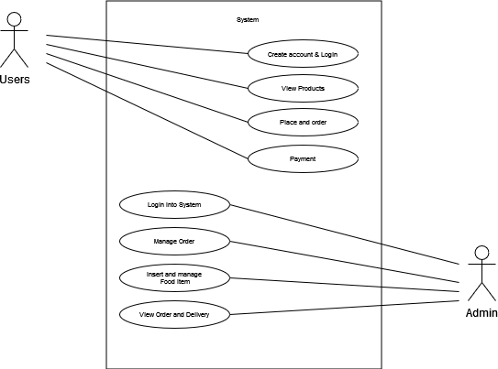

Figure 3. : Use Case Diagram

### Non-functional requirement

**Software requirements**

Operating system: Windows 7 \ windows 10

Server: Apache 2.4.4

Front-end: PHP 5.4.19 (Framework: Bootstrap and css)

Back-end: MySQL 5.5.32(using phpMyAdmin 4.0.6)

We have used XAMPP which is a free and Open-Source Cross-Platform Web Server Solution Stack. It comes with Apache Web Server, MySQL Database and PHP*.*

**Hardware requirements**

Processor: Intel dual core or above Processor Speed: 1.0GHZ or above RAM: 1 GB RAM or above

Hard Disk: 20 GB hard disk or above

### Feasibility Analysis

The feasibility analysis evaluates the practicality and viability of the Thali.com project, considering various aspects such as technical, operational, economic, legal, and scheduling factors. The analysis serves as a critical step in determining whether the project is worth pursuing and identifying potential challenges that need to be addressed.

### Technical

The Thali.com platform requires technical infrastructure for its development, such as a reliable server, database, and programming languages such as HTML, CSS, JavaScript, PHP, and SQL. The platform must also be optimized for various devices such as mobile, tablet, and desktop. These technical requirements are feasible to fulfill, and the required resources are readily available in the market.

### Operational

The Thali.com platform requires operational procedures for its development and deployment, such as user and restaurant registration, menu management, order management, delivery management, and customer feedback management. These procedures are feasible to develop and deploy, and a team of skilled individuals can manage them efficiently.

### Economic

The cost for H/W and S/W is feasible, as it requires investment at the start of the system of computer, printer etc. But the Store for which we are developing this project doesn’t possess any system. So, at the start they need to invest for this system working. The current manual system they require regular investment also require more storage space inform of cupboards. So, the software system which we are developing is feasible in economic aspects. Time-based study: - This is analysis of the time for required to achieve a return on investment (ROI) and benefits comes from the product system. The future value of a project is also depending upon it quality and factor. Cost-based study:

It is most important to identity cost and benefit factors and ROI which can be categorized as follows:

* + - * + Development costs
        + Operating costs
        + Cost of hardware
        + Cost of Operating system software
        + Cost of Application software
        + Cost of Documentation preparation

### Schedule

Schedule time evaluation is the most important consideration in the development of project. The time schedule requires for the development of this project is very important. Proposed system would be designed as per the time calculated. Likelihood that timeframes can be met and that this adequate to meet organization's needs.

Table 3. : Gantt Chart

|  |  |  |  |  |  |  |
| --- | --- | --- | --- | --- | --- | --- |
| **Task/Month** | **1st -2nd**  **Week** | **3rd - 4th**  **week** | **5th – 6th**  **week** | **7th – 10th**  **week** | **11th**  **week** | **12th**  **week** |
| **Requirement**  **Gathering** |  |  |  |  |  |  |
| **Planning** |  |  |  |  |  |  |
| **Design** |  |  |  |  |  |  |
| **Development** |  |  |  |  |  |  |
| **Testing** |  |  |  |  |  |  |
| **Deployment** |  |  |  |  |  |  |
| **Documentation** |  |  |  |  |  |  |

### Data Modelling(ER-Diagram)

Entity Relationship Diagram of Thali.

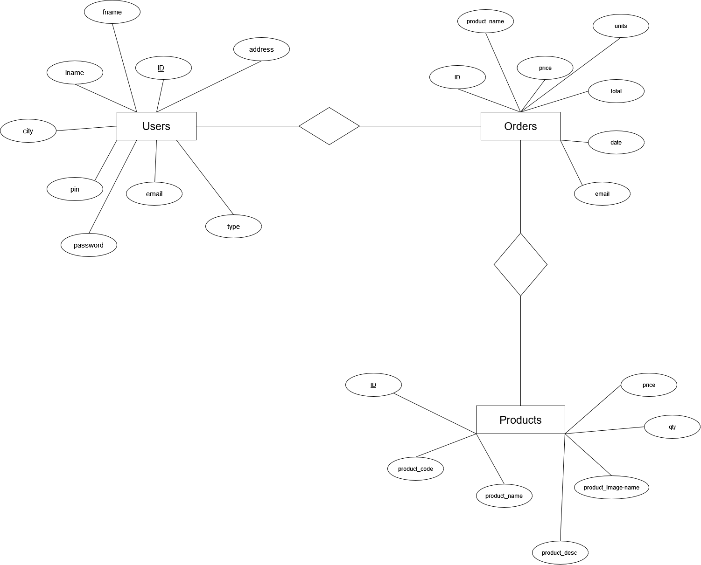

Figure 3. : ER Diagram

### Process Modelling

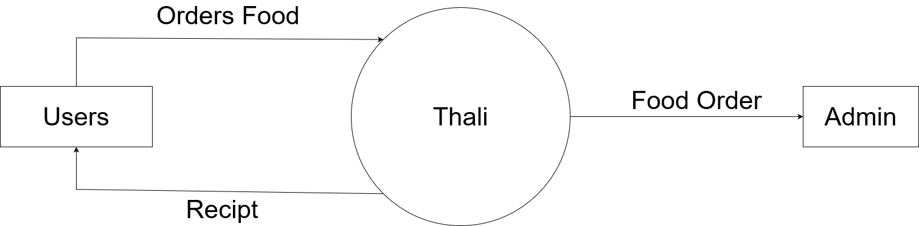

Figure 3. : Context Diagram

Figure 3. 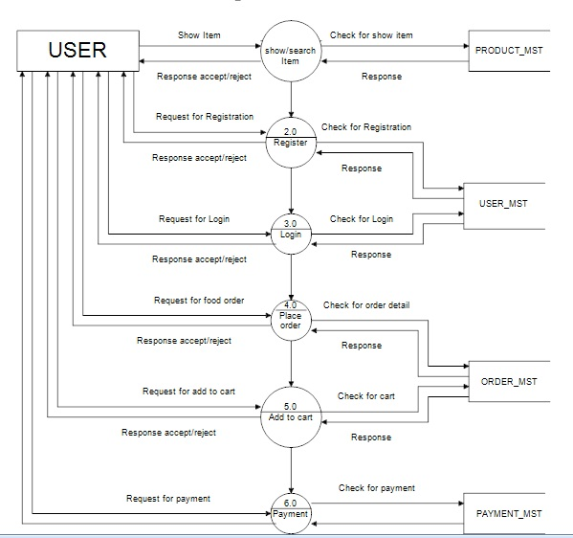: Level 1 DFD for User

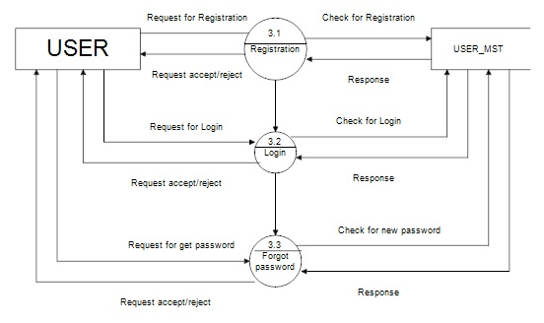Figure 3. : level 2 DFD for User

Figure 3. : 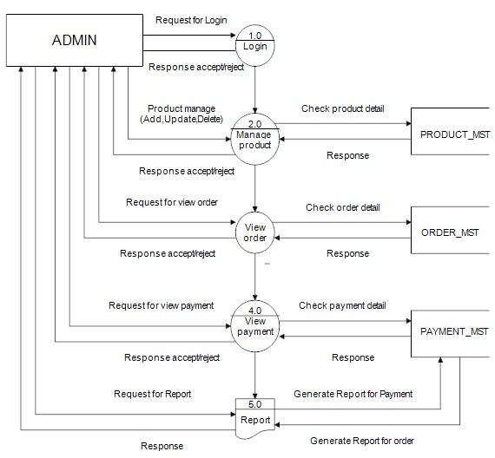Admin Side DFD

## System Design

### Architectural Design

Architectural design is a discipline that focuses on covering and meeting the needs and demands, to create living spaces, using certain tools and especially, creativity. Therefore, the aim is to combine the technological and the aesthetic, despite the general belief that architecture is only a technological task.

In the same way, it mixes design, understood as the creative process, and architecture, which is based on the creation and presentation of solutions at a technical level.We have developed the required system that makes uses of the internet and computer peripherals, and smart phones. This system is supposed by any things that can access internet. 

Figure 3. : Architectural Design

### Database Schema Design

Database is a large collection of inter-related data stored with minimum redundancy and used especially for rapid search and retrieval. The general objective is to make information secure, flexible for the user and to reduce data duplication.

#### Database Schema

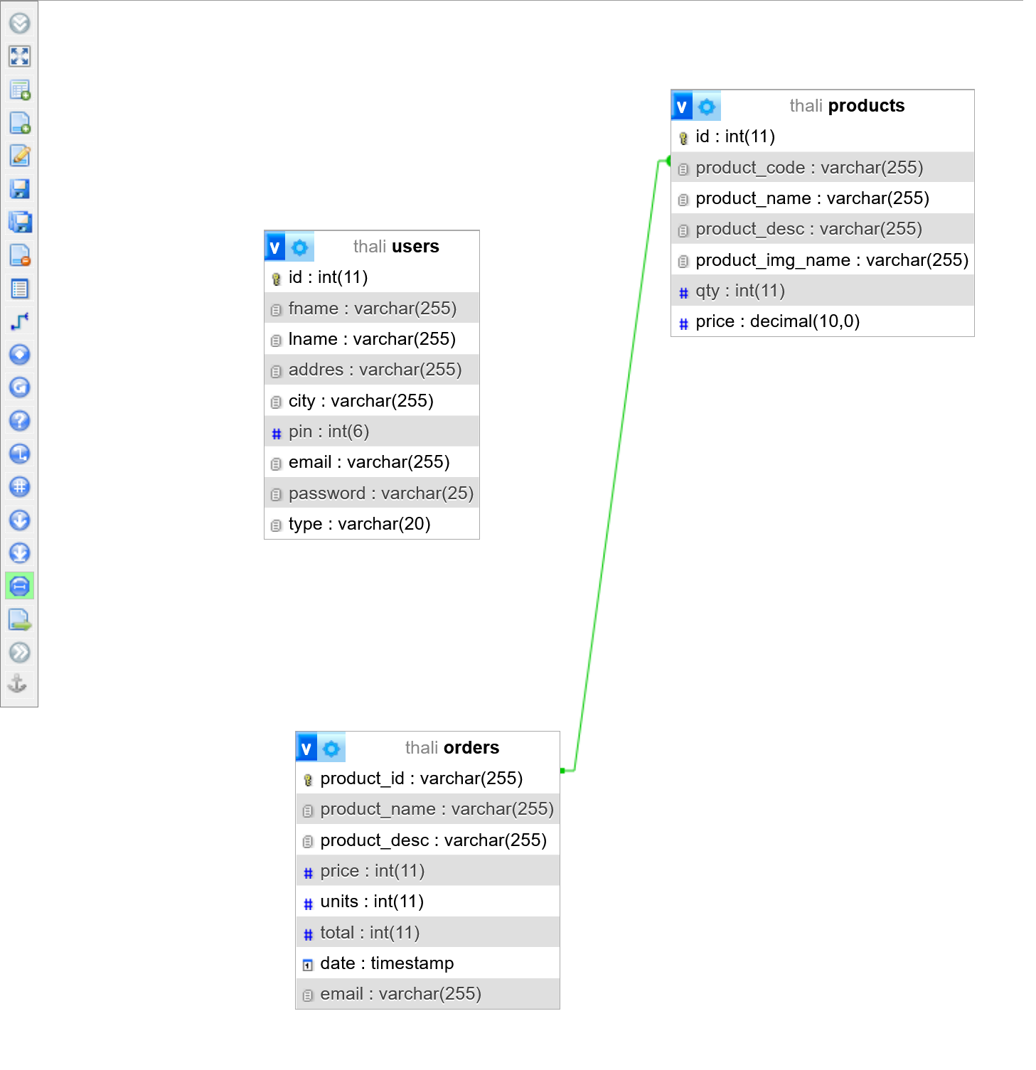

Figure 3. : Database Schema Diagram

### Interface Design

The interface design phase of the Thali.com project focuses on creating an intuitive and user-friendly visual representation of the platform's functionalities. This phase is crucial as it directly impacts user experience and engagement. Here's how the interface design process can be structured:

* **User-Centered Design Approach:**
  + Prioritize the needs and preferences of users, including customers, restaurants, and delivery persons.
  + Gather user feedback through surveys, focus groups, or user interviews to understand their expectations and pain points.
  + Develop user personas that represent different types of users to guide design decisions.
* **Wire framing:**
  + Create low-fidelity wireframes that outline the basic layout, structure, and placement of elements on each screen.
  + Wireframes help visualize the user journey, ensuring that essential features are included and the interface is intuitive.
* **Prototyping:**
  + Develop interactive prototypes using tools like Figma.
  + Prototypes allow users to interact with the platform's interface, giving you insights into usability and identifying areas for improvement.
* **Visual Design:**
  + Define the color scheme, typography, and visual elements that align with Thali.com's brand identity.
  + Create high-fidelity mockups that showcase the final look and feel of the user interface.

# CHAPTER 4: IMPLEMENTAION AND TESTING

## Implementation

### Tools Used (CASE tools, Programming languages, Database platforms)

Before diving into the actual code, it's essential to create artifacts like Entity-Relationship (ER) diagrams, Flowcharts, and Data Flow Diagrams (DFD) using tools like Word and visual-paradigm.com online editor. These artifacts provide a visual representation of the system, aiding in better understanding and planning.

The chosen server-side scripting language for the implementation is PHP. PHP serves as an intermediary between the frontend and backend, handling user inputs and performing manipulations, validations, and data processing. For the frontend, HTML, CSS, and the Bootstrap framework are employed to create a user-friendly and responsive interface. On the backend, MySQL Server is utilized to store, update, and retrieve data, allowing PHP to interact with the database and present information to the user's browser.

In summary, the implementation phase involves using PHP to process user inputs, perform data manipulations, and communicate with the backend MySQL Server. The frontend is developed using HTML, CSS, and Bootstrap, providing a well-designed and interactive interface to the users. This well-structured approach ensures the successful development of the software system..

### Implementation Details of Modules (Description of procedures/functions)

Following are all the modules designed for Thali.com.

#### Admin Module

This module is only authorized for admin. Only admin can access the functionality created over there. Admin need to login to access to this panel after authenticated they redirect to the admin page. Admin can insert the food menu and category details, add it, delete it if necessary. Moreover, Admin can see the list of order details and can delete after deliver to the Customer.

#### Food Details Module

In this module user can see all the list of the products available with number of rated in each product. Anyone can visit this page or interface. In this page image of food, category of food, name of food and purchase options are shown to the user. Moreover, user can click for the purchase option and then they will be redirect to the register/login page where they can fill their credentials to register or login.

#### User Module

In this module only authorized user after login can choose the food and click on add to cart and then checkout. user can also do logout.

#### Payment Module

In this module payment is done via cash only but only when the user add item to the cart and details such as phone, email, name, address is provided.

## Testing

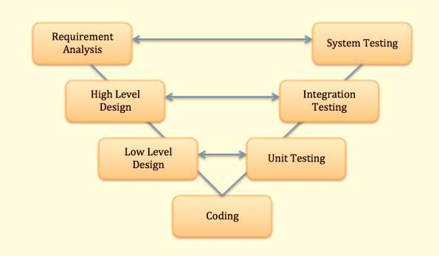Among disparate available models and methods for testing we’ve elected for the V-model software testing in which we will test our software from the core to the most outer module or layer of the software.

Figure 4. : V-Model

### Test Cases for Unit Testing

First stage of the V model is the Unit Testing, where each and every unit/ component of the model used in several functions and tasks are first tested individually to find defects or incompatibilities in a faster way. This lets us observe errors or bugs and helps us devise solutions against them at a low level as if, we can treat the errors and issues examining the root of the problem which eventually will help us treat future problems too.

The modules in our project are the User Module and the Administration Module, each which have several more components with functions together working as a whole. E.g., the user’s side’s operations such as creating an account for the booking purpose and getting logged in to the website. so, we need to test all these functions respectively with the worst-case scenarios for them. The Administrator module includes the same The next unit which incurred the process to store the records in our created database and then using it and viewing it for the administration purpose. All these units are tested one by one in this UNIT TESTING.

### Test Cases for System Testing

The objective is to make the user feel great about the project and then make him understand the quality of the software. The lesser the complexity of the project, the more the user will prefer to use the software on his desire. Our software satisfies that property.

In this way, we have carried out testing for our application in a solicitous way.

Table 4. : Admin Login Test

|  |  |  |  |  |  |  |
| --- | --- | --- | --- | --- | --- | --- |
| **Test**  **Case ID** | **Test Scenario** | **Test Steps** | **Test Date** | **Expected Results** | **Actual Results** | **Pass/ Fail** |
| TC1 | Check Admin Login with valid data | 1. Go to site http://localhost/thali/index.php 2. Enter Email 3. Enter Password 4. Click Login | Email=[admin@](mailto:admin@gmail.com) [gmail.com](mailto:admin@gmail.com) Password=admi n | Admin should be login into application | As Expected | Pass |
| TC2 | Check admin Login with invalid Data | 1. Go to site 2. Enter Email 3. Enter Password 4. Click Login | Email=[admin1](mailto:admin1@gmail.com) [@gmail.com](mailto:admin1@gmail.com) Password=admi n12346 | Admin should not be login into application | As Expected | Pass |

Table 4. : User Registration With Email

|  |  |  |  |  |  |  |
| --- | --- | --- | --- | --- | --- | --- |
| **Test Case ID** | **Test Scenario** | **Test Steps** | **Test Date** | **Expected Results** | **Actual Results** | **Pass/ Fail** |
| TC3 | Check Customer Register with valid email | 1. Go to site <http://localhost>   /thali/index.php   1. First Name 2. Last Name 3. Enter Address 4. Enter pincode 5. Enter Email 6. Enter Password 7. Click Sign up | Name= User  Email=c1@thali.com  Password=pass1 | User should  get register  if email  is  valid. | As Expected | Pass |
| TC4 | Check Customer Register with repeated email | 1. First Name 2. Last Name 3. Enter Address 4. Enter pincode 5. Enter Email 6. Enter Password 7. Click Sign up | Name=Random User  Email=random.com  Password=12345 | Email is not valid  message  should  show. | As  Expected | Pass |

Table 4. : User Login with Email

|  |  |  |  |  |  |  |
| --- | --- | --- | --- | --- | --- | --- |
| **Test Case ID** | **Test Scenario** | **Test Steps** | **Test Date** | **Expected Results** | **Actual Results** | **Pass/ Fail** |
| TC5 | Check Customer Login with valid Data | 1. Go to site http://localhost/thali/index.php 2. Enter Email 3. Enter Password 4. Click Login | Email= c1@thali.com  Password=pass1 | Customer should be login into application | As Expected | Pass |
| TC6 | Check Customer Login with not registered Data | 1. Go to site 2. Enter Email 3. Enter Password 4. Click Login | Email= random.com Password=12345 | Customer should not be login into application | As Expected | Pass |

Table 4. 4: System Testing

|  |  |  |  |  |  |  |
| --- | --- | --- | --- | --- | --- | --- |
| **Test Case ID** | **Test Scenario** | **Test Steps** | **Test Date** | **Expected Results** | **Actual Results** | **Pass/ Fail** |
| TC7 | Adding Item to Cart | 1. Go to site http://localhost/thali/food.php 2. Browse Desire Product 3. Click Add to Cart | 7/19/22023 | Product should be added on Cart | As Expected | Pass |
| TC8 | Check to purchase product | 1. Go to site 2. login 3. Click on Cart 4. Click on COD 5. Order Placed | 7/19/22023 | Ordered should be placed | As Expected | Pass |
| TC9 | Check Previous Order | 1. Go to site 2. login 3. Click on Orders 4. Check Previous Order | 7/19/22023 | Previous Orders Displayed | As Expected | Pass |
| TC10 | To Check LogOut From System | 1. Go to site 2. Login 3. Click on Logout | 7/19/22023 | User should be Logged out | As Expected | Pass |

# CHAPTER 5: CONCLUSION AND FUTURE RECOMMENDATION

## Lesson Learnt / Outcome

Throughout the development of Thali.com, several valuable lessons were learned, leading to significant outcomes that shaped the project's success and impact:

1. Customer-Centric Approach: The importance of adopting a customer-centric approach was emphasized during the project. Understanding and addressing the needs, preferences, and pain points of customers played a pivotal role in designing a platform that resonated with users and enhanced their overall experience.
2. Continuous Improvement: Embracing a culture of continuous improvement proved crucial. Feedback from users, restaurants, and delivery persons was actively sought and incorporated into the platform's development. This iterative process ensured that Thali.com evolved to meet the changing demands of the food delivery market.
3. Technology Advancements: Leveraging automation and real-time tracking technologies proved to be a game-changer. These innovations streamlined the order fulfillment process, reduced errors, and offered customers transparency and control over their deliveries, leading to increased satisfaction.
4. Adaptability and Flexibility: Flexibility was key in navigating unforeseen challenges and changes. The ability to adapt to evolving circumstances and refine strategies allowed Thali.com to remain competitive and responsive to market dynamics.

Outcome:

As a result of the lessons learned, Thali.com achieved notable outcomes and impacts in the food delivery industry:

1. Enhanced Customer Experience: Thali.com became synonymous with a seamless, user-friendly, and convenient food ordering and delivery experience. The real-time tracking feature empowered customers with control and confidence, resulting in increased customer loyalty.
2. Increased Efficiency: The platform's automation significantly improved the order processing time, reducing manual efforts and minimizing errors. This led to faster order confirmations and a smoother order fulfillment process.
3. Improved Restaurant Performance: Partnering with Thali.com proved advantageous for restaurants, leading to increased visibility, streamlined order management, and improved efficiency in fulfilling customer orders.
4. Positive Industry Disruption: Thali.com's success and innovative practices disrupted traditional food delivery services, inspiring others in the industry to adopt automation and real-time tracking, ultimately benefiting the entire food delivery ecosystem.

## Conclusion

The development of Thali.com has been a journey marked by innovation, perseverance, and a commitment to delivering excellence in the food delivery industry. Through a customer-centric approach and leveraging cutting-edge technologies, Thali.com has emerged as a transformative platform, revolutionizing the way food is ordered and delivered.

By conducting a thorough system analysis and understanding the challenges faced by traditional manual systems, Thali.com was designed to address these pain points. The integration of automation and real-time tracking has led to enhanced efficiency, reduced errors, and improved overall customer satisfaction. The platform's intuitive user interface and continuous improvement initiatives have garnered positive feedback from users and partners, solidifying Thali.com as a market leader.

Through partnerships with restaurants and delivery persons, Thali.com has created a dynamic ecosystem that benefits all stakeholders. Restaurants enjoy increased visibility and streamlined order management, while delivery persons experience optimized routes and improved efficiency.

In conclusion, Thali.com stands as a testament to the power of technology and customer-centricity in revolutionizing an industry. The journey of Thali.com has been one of growth, learning, and positive disruption, leaving a lasting mark on the food delivery landscape. As we move forward, Thali.com remains committed to its mission of providing a seamless and efficient food delivery experience, enriching the lives of customers, restaurants, and delivery persons alike.

## Future Recommendations

While Thali.com has achieved remarkable success and made a significant impact on the food delivery industry, there are several future recommendations to further enhance the platform's capabilities and maintain its position as a market leader:

1. Live Tracking of Delivery Boy: Implement real-time tracking of the delivery person's location on the customer's app or website. This feature will allow customers to track the delivery person's exact location and estimated time of arrival, enhancing transparency and reducing anxiety about the order's status. Live tracking will provide customers with a sense of control and assurance during the delivery process.
2. Restaurant Updates about the Order: Introduce a notification system that keeps customers informed about the order's progress at the restaurant. Customers should receive real-time updates when the restaurant starts preparing the order, when it is ready for pickup, and when it is handed over to the delivery person. This proactive communication will keep customers engaged and informed, leading to a seamless and delightful ordering experience.
3. Interactive Chat Support: Implement an interactive chat support feature to facilitate instant communication between customers, restaurants, and delivery persons. Customers can inquire about order details, request modifications, and resolve any issues through the chat support. This feature will enhance customer satisfaction by providing swift and efficient support.

By incorporating these enhancements, Thali.com can create a dynamic and innovative food delivery platform that not only meets current expectations but also anticipates and exceeds the future needs of its users. Embracing technology-driven features will solidify Thali.com as a market leader, providing a cutting-edge and unparalleled food delivery experience for customers, restaurants, and delivery persons alike.

# Gag

# Reference

* + S. Dwivedi, “Food Delivery System,” Merokinmel.com. [Online]. Available: https://www.merokinmel.com/. [Accessed: 05-Apr-2023].
  + Tutorials Point, “SDLC - Waterfall Model,” Tutorials Point. [Online]. Available: https://www.tutorialspoint.com/sdlc/sdlc_waterfall_model.htm#. [Accessed: 05-Apr-2023].
  + Tutorials Point, “SDLC - Agile Model,” Tutorials Point, 2001. [Online]. Available: https://www.tutorialspoint.com/sdlc/sdlc_agile_model.htm. [Accessed: 06-Apr-2023].

# Appendices

# C:\Users\siddh\AppData\Local\Microsoft\Windows\INetCache\Content.Word\Screenshot 2023-08-03 at 16-23-12 Home.pngScreen Shots

Figure 7. : Home Page

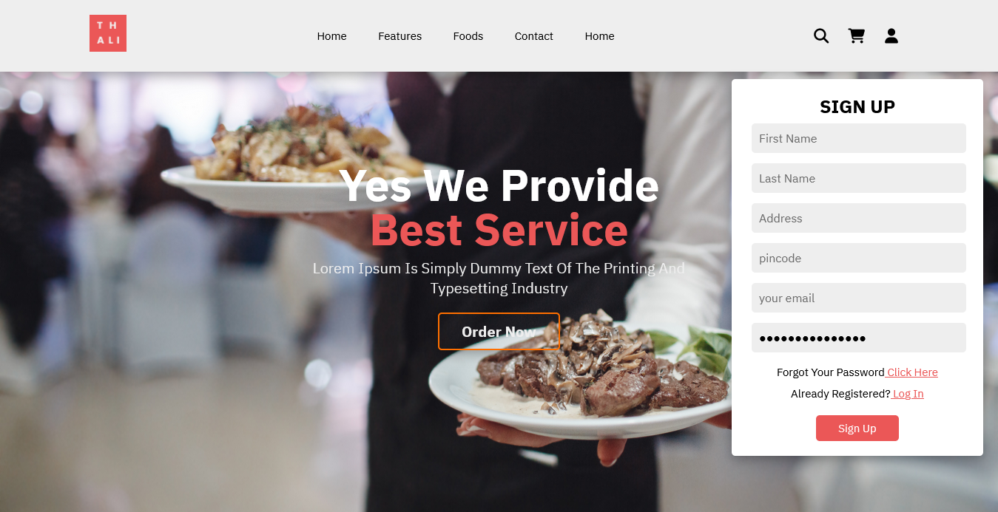Figure 7. : Sign Up

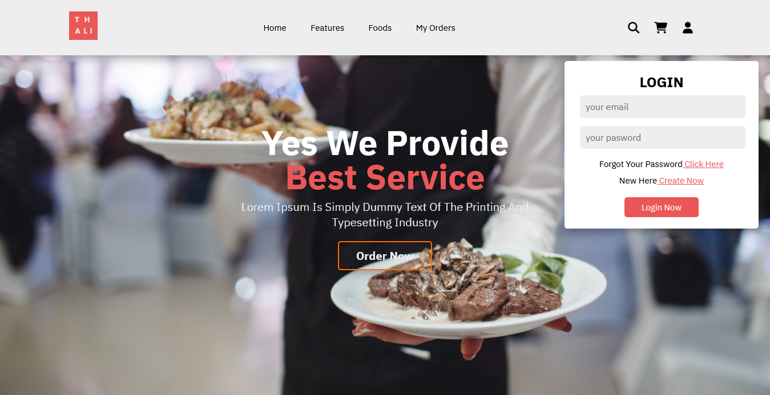

Figure 7. : Login page

Figure 7. 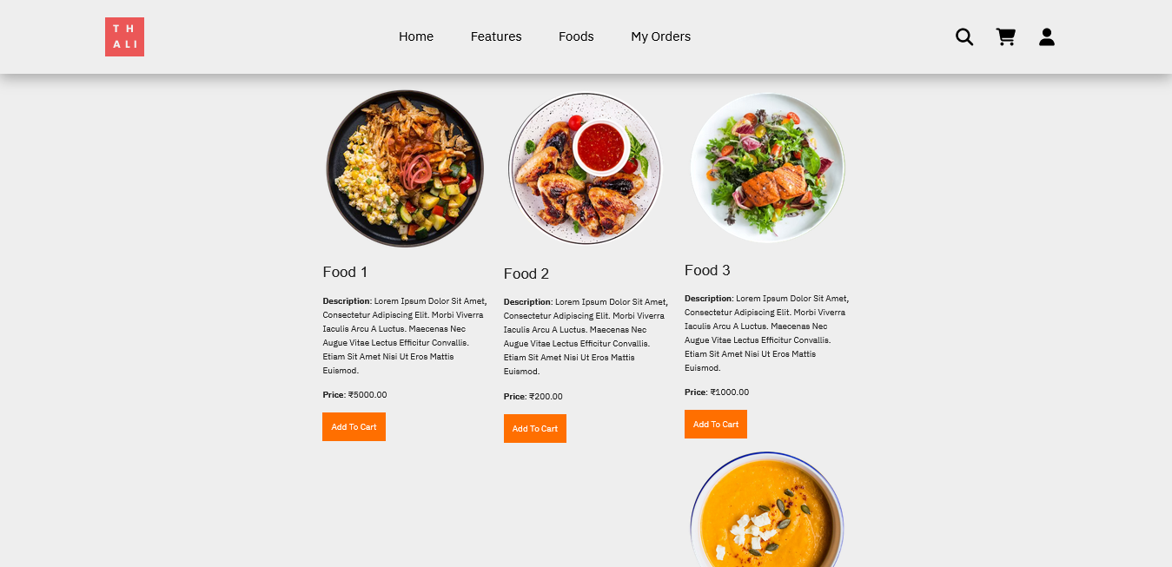: Food Listing

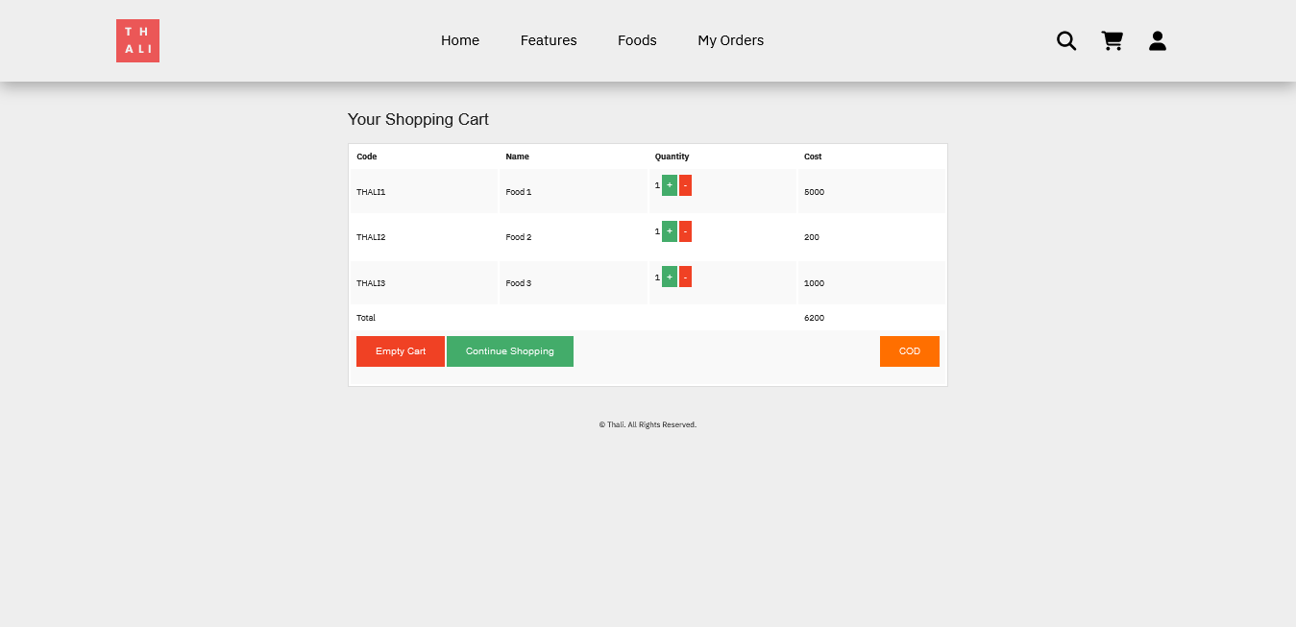

Figure 7. : Cart

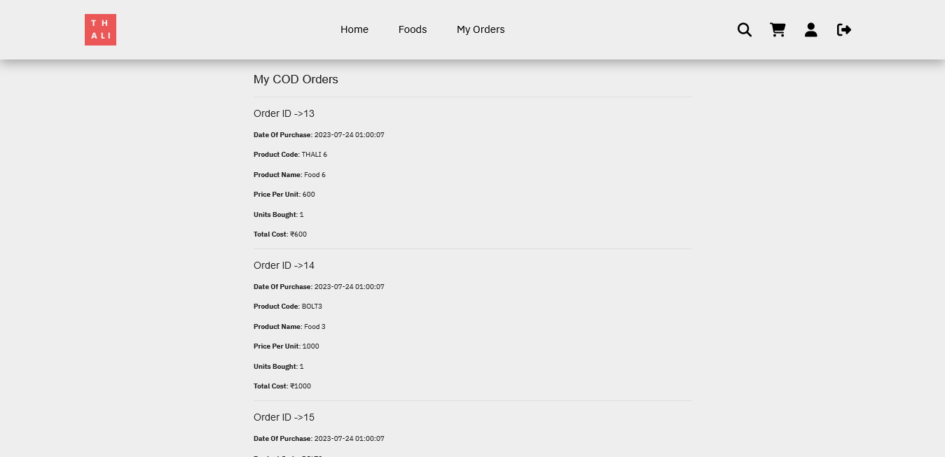Figure 7. : My Orders

Figure 7. 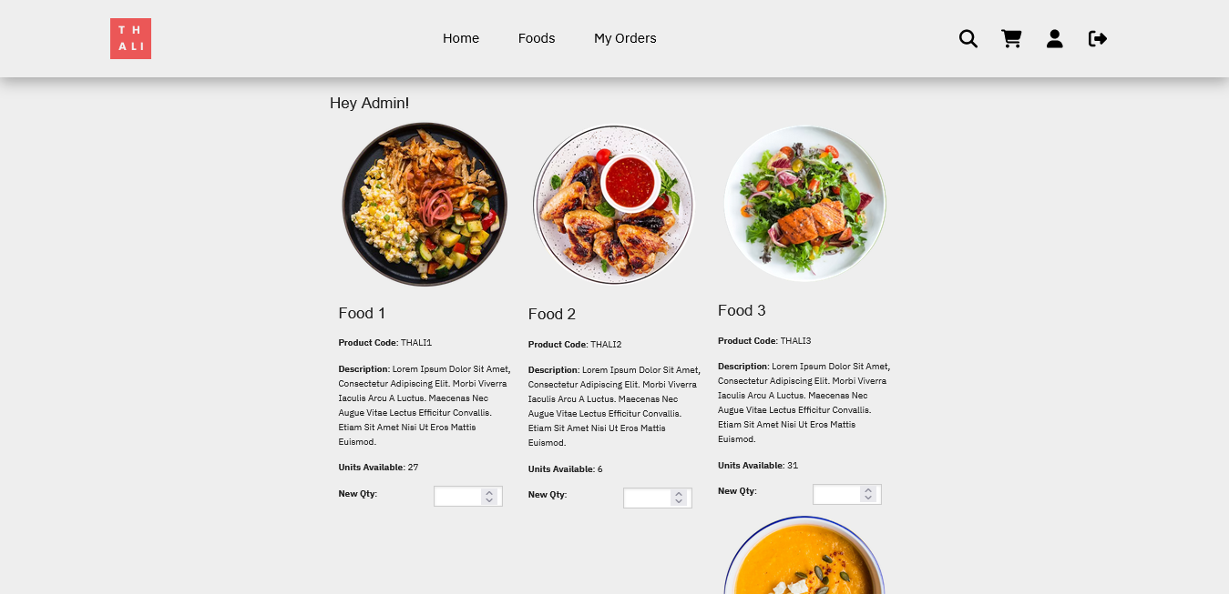: Admin Dashboard

# Source Codes

# Home Page along with login card, Products page, Contact Page.

<?php

session_start();

?>

<!DOCTYPE html>

<html lang="en">

<head>

    <meta charset="utf-8">

    <meta name="viewport" content="width= device-width, initial-scale=1.0">

    <meta http-equiv="X-UA-Compatible" content="ie=edge">

    <title>Home</title>

    <link rel="stylesheet" href="https://cdn.jsdelivr.net/npm/swiper@9/swiper-bundle.min.css" />

    <!-- custom css  -->

    <link rel="stylesheet" href="css/style.css">

    <!-- font awesome cdn link -->

    <link rel="stylesheet" href="https://cdnjs.cloudflare.com/ajax/libs/font-awesome/6.4.0/css/all.min.css">

    <!-- favicon -->

    <link rel="shortcut icon" href="images/thali.png">

</head>

<body>

    <!-- header section -->

    <header class="header">

        <a class="logo" href="index.php">

            <img src="images/thali.png" alt="Thali.com Logo" height="50">

        </a>

        <nav class="navbar">

            <a href="#home">Home</a>

            <a href="#features">Features</a>

            <a href="products.php">Foods</a>

            <a href="orders.php">My Orders</a>

        </nav>

        <div class="icons">

            <div class="fas fa-bars" id="menu-bars"></div>

            <div class="fas fa-search" id="search-icon"></div>

            <a href="cart.php"><div class="fas fa-shopping-cart" id="cart-icon"></div></a>

            <div class="fas fa-user" id="login-icon"></div>

        </div>

        <form action="" class="search-form">

            <input type="search" id="search-box" placeholder="search here...">

            <label for="search-box" class="fas fa-search"></label>

        </form>

        <form action="verify.php" method="post" class="login-form">

            <h3>Login</h3>

            <input type="email" placeholder="your email" class="box" name="username">

            <input type="password" placeholder="your pasword" class="box" name="password">

            <p>forgot your password<a href="#"> click Here</a> </p>

            <p>new here<a href="createnew.php"> create now</a> </p>

            <input type="submit" value="login now" class="btn">

        </form>

    </header>

    <!-- header section ends here -->

    <!-- hero section starts  -->

    <section class="home" id="home">

        <div class="content">

            <h1>Yes We Provide <br><span>Best Service</span></h1>

            <p> Lorem Ipsum is simply dummy text of the printing and typesetting industry</p>

            <a href="products.php" class="btn">Order Now</a>

        </div>

    </section>

    <!-- hero sections ends -->

    <!-- Features section starts  -->

    <section class="features" id="features">

        <h1 class="heading"> our <span>features</span> </h1>

        <div class="box-container">

            <div class="box">

                <img src="images/chef.png" alt="">

                <h3>Quality Food</h3>

                <p> dummy text here</p>

                <a href="#" class="btn">read more</a>

            </div>

            <div class="box">

                <img src="images/chef.png" alt="">

                <h3>Free Delivery</h3>

                <p> dummy text here</p>

                <a href="#" class="btn">read more</a>

            </div>

            <div class="box">

                <img src="images/chef.png" alt="">

                <h3>Easy Payments</h3>

                <p> dummy text here</p>

                <a href="#" class="btn">read more</a>

            </div>

        </div>

    </section>

    <!-- Features section ends -->

    <!-- produts section starts -->

    <section class="products" id="foods">

        <h1 class="heading"> our <span>products</span> </h1>

        <div class="swiper product-slider">

            <div class="swiper-wrapper first-child">

                <div class="swiper-slide box">

                    <img src="images/Food 1.jpg" alt="">

                    <h3>Food 1</h3>

                    <div class="price">$50</div>

                    <div class="stars">

                        <i class="fas fa-star"></i>

                        <i class="fas fa-star"></i>

                        <i class="fas fa-star"></i>

                        <i class="fas fa-star"></i>

                        <i class="fas fa-star-half-alt"></i>

                    </div>

                </div>

                <div class="swiper-slide box">

                    <img src="images/Food 2.jpg" alt="">

                    <h3>Food 1</h3>

                    <div class="price">$50</div>

                    <div class="stars">

                        <i class="fas fa-star"></i>

                        <i class="fas fa-star"></i>

                        <i class="fas fa-star"></i>

                        <i class="fas fa-star"></i>

                        <i class="fas fa-star-half-alt"></i>

                    </div>

                </div>

                <div class="swiper-slide box">

                    <img src="images/Food 3.jpg" alt="">

                    <h3>Food 1</h3>

                    <div class="price">$50</div>

                    <div class="stars">

                        <i class="fas fa-star"></i>

                        <i class="fas fa-star"></i>

                        <i class="fas fa-star"></i>

                        <i class="fas fa-star"></i>

                        <i class="fas fa-star-half-alt"></i>

                    </div>

                </div>

                <div class="swiper-slide box">

                    <img src="images/Food 4.jpg" alt="">

                    <h3>Food 1</h3>

                    <div class="price">$50</div>

                    <div class="stars">

                        <i class="fas fa-star"></i>

                        <i class="fas fa-star"></i>

                        <i class="fas fa-star"></i>

                        <i class="fas fa-star"></i>

                        <i class="fas fa-star-half-alt"></i>

                    </div>

                </div>

                <div class="swiper-slide box">

                    <img src="images/Food 4.jpg" alt="">

                    <h3>Food 1</h3>

                    <div class="price">$50</div>

                    <div class="stars">

                        <i class="fas fa-star"></i>

                        <i class="fas fa-star"></i>

                        <i class="fas fa-star"></i>

                        <i class="fas fa-star"></i>

                        <i class="fas fa-star-half-alt"></i>

                    </div>

                </div>

                <div class="swiper-slide box">

                    <img src="images/Food 4.jpg" alt="">

                    <h3>Food 1</h3>

                    <div class="price">$50</div>

                    <div class="stars">

                        <i class="fas fa-star"></i>

                        <i class="fas fa-star"></i>

                        <i class="fas fa-star"></i>

                        <i class="fas fa-star"></i>

                        <i class="fas fa-star-half-alt"></i>

                    </div>

                </div>

                <div class="swiper-slide box">

                    <img src="images/Food 4.jpg" alt="">

                    <h3>Food 1</h3>

                    <div class="price">$50</div>

                    <div class="stars">

                        <i class="fas fa-star"></i>

                        <i class="fas fa-star"></i>

                        <i class="fas fa-star"></i>

                        <i class="fas fa-star"></i>

                        <i class="fas fa-star-half-alt"></i>

                    </div>

                </div>

                <div class="swiper-slide box">

                    <img src="images/Food 4.jpg" alt="">

                    <h3>Food 1</h3>

                    <div class="price">$50</div>

                    <div class="stars">

                        <i class="fas fa-star"></i>

                        <i class="fas fa-star"></i>

                        <i class="fas fa-star"></i>

                        <i class="fas fa-star"></i>

                        <i class="fas fa-star-half-alt"></i>

                    </div>

                </div>

            </div>

            <div class="swiper product-slider">

                <div class="swiper-wrapper">

                    <div class="swiper-slide box">

                        <img src="images/Food 6.jpg" alt="">

                        <h3>Food 1</h3>

                        <div class="price">$50</div>

                        <div class="stars">

                            <i class="fas fa-star"></i>

                            <i class="fas fa-star"></i>

                            <i class="fas fa-star"></i>

                            <i class="fas fa-star"></i>

                            <i class="fas fa-star-half-alt"></i>

                        </div>

                    </div>

                    <div class="swiper-slide box">

                        <img src="images/Food 7.jpg" alt="">

                        <h3>Food 1</h3>

                        <div class="price">$50</div>

                        <div class="stars">

                            <i class="fas fa-star"></i>

                            <i class="fas fa-star"></i>

                            <i class="fas fa-star"></i>

                            <i class="fas fa-star"></i>

                            <i class="fas fa-star-half-alt"></i>

                        </div>

                    </div>

                    <div class="swiper-slide box">

                        <img src="images/Food 8.jpg" alt="">

                        <h3>Food 1</h3>

                        <div class="price">$50</div>

                        <div class="stars">

                            <i class="fas fa-star"></i>

                            <i class="fas fa-star"></i>

                            <i class="fas fa-star"></i>

                            <i class="fas fa-star"></i>

                            <i class="fas fa-star-half-alt"></i>

                        </div>

                    </div>

                    <div class="swiper-slide box">

                        <img src="images/Food 9.jpg" alt="">

                        <h3>Food 1</h3>

                        <div class="price">$50</div>

                        <div class="stars">

                            <i class="fas fa-star"></i>

                            <i class="fas fa-star"></i>

                            <i class="fas fa-star"></i>

                            <i class="fas fa-star"></i>

                            <i class="fas fa-star-half-alt"></i>

                        </div>

                    </div>

                </div>

            </div>

            <div class="swiper-pagination"></div>

        </div>

    </section>

    <!-- product section ends here -->

    <!-- catagory section starts here -->

    <section class="catagories" id="restarunts">

        <h1 class="heading"> Partnered <span>Restaurants</span> </h1>

        <div class="box-container">

            <div class="box">

                <img src="images/restro 2.jpg" alt="">

                <div class="content">

                    <h3>Restaurant 1</h3>

                    <p>dummy text here</p>

                    <div class="stars">

                        <i class="fas fa-star"></i>

                        <i class="fas fa-star"></i>

                        <i class="fas fa-star"></i>

                        <i class="fas fa-star"></i>

                        <i class="fas fa-star-half-alt"></i>

                    </div>

                    <a href="#" class="btn">Order Now</a>

                </div>

            </div>

            <div class="box">

                <img src="images/restro 2.jpg" alt="">

                <div class="content">

                    <h3>Restaurant 2</h3>

                    <p>dummy text here</p>

                    <div class="stars">

                        <i class="fas fa-star"></i>

                        <i class="fas fa-star"></i>

                        <i class="fas fa-star"></i>

                        <i class="fas fa-star"></i>

                        <i class="fas fa-star-half-alt"></i>

                    </div>

                    <a href="#" class="btn">Order Now</a>

                </div>

            </div>

            <div class="box">

                <img src="images/restro 3.jpg" alt="">

                <div class="content">

                    <h3>Restaurant 3</h3>

                    <p>dummy text here</p>

                    <div class="stars">

                        <i class="fas fa-star"></i>

                        <i class="fas fa-star"></i>

                        <i class="fas fa-star"></i>

                        <i class="fas fa-star"></i>

                        <i class="fas fa-star-half-alt"></i>

                    </div>

                    <a href="#" class="btn">Order Now</a>

                </div>

            </div>

            <div class="box">

                <img src="images/restro 3.jpg" alt="">

                <div class="content">

                    <h3>Restaurant 4</h3>

                    <p>dummy text here</p>

                    <div class="stars">

                        <i class="fas fa-star"></i>

                        <i class="fas fa-star"></i>

                        <i class="fas fa-star"></i>

                        <i class="fas fa-star"></i>

                        <i class="fas fa-star-half-alt"></i>

                    </div>

                    <a href="#" class="btn">Order Now</a>

                </div>

            </div>

    </section>

    <!-- catagory section ends here -->

    <!-- Team section starts here -->

    <section class="team" id="team">

        <h1 class="heading"> Brain Behind <span>Thali</span> </h1>

        <div class="box-container">

            <div class="box">

                <img src="images/Mr Sidd.png" alt="">

                <div class="info">

                    <h3>Siddhartha Dwivedi</h3>

                    <p> Graphic and UI/UX Designer </p>

                </div>

                <ul class="social-icons">

                    <a href="https://facebook.com/thesiddartt">

                        <li class="fa-brands fa-facebook-f"></li>

                    </a>

                    <a href="https://instagram.com/the_siddart">

                        <li class="fa-brands fa-instagram"></li>

                    </a>

                    <a href="https://facebook.com/thesiddartt">

                        <li class="fa-brands fa-linkedin-in"></li>

                    </a>

                </ul>

            </div>

            <div class="box">

                <img src="images/new-moon.png" alt="">

                <div class="info">

                    <h3>Seema Bhattarai</h3>

                    <p> dummy text here</p>

                </div>

                <ul class="social-icons">

                    <li class="fa-brands fa-facebook-f"></li>

                    <li class="fa-brands fa-instagram"></li>

                    <li class="fa-brands fa-linkedin-in"></li>

                </ul>

            </div>

        </div>

    </section>

    <!-- Team section ends here -->

    <!-- Customer Review section starts -->

    <section class="review" id="review">

        <h1 class="heading">What Our <span>User's Say</span></h1>

        <div class="swiper review-slider">

            <div class="swiper-wrapper">

                <div class="swiper-slide box">

                    <img src="images/Profile_unblur.png" alt="">

                    <p> Lorem ipsum dolor sit amet consectetur adipisicing elit. Vero, officiis illum reiciendis nobis

                        et error harum blanditiis consequatur excepturi voluptas!</p>

                    <h3> Siddhartha Dwivedi</h3>

                    <div class="stars">

                        <i class="fas fa-star"></i>

                        <i class="fas fa-star"></i>

                        <i class="fas fa-star"></i>

                        <i class="fas fa-star"></i>

                        <i class="fas fa-star-half-alt"></i>

                    </div>

                </div>

                <div class="swiper-slide box">

                    <img src="images/Food 19.jpg" alt="">

                    <p> Lorem ipsum dolor sit amet consectetur adipisicing elit. Vero, officiis illum reiciendis nobis

                        et error harum blanditiis consequatur excepturi voluptas!</p>

                    <h3> Random1</h3>

                    <div class="stars">

                        <i class="fas fa-star"></i>

                        <i class="fas fa-star"></i>

                        <i class="fas fa-star"></i>

                        <i class="fas fa-star"></i>

                        <i class="fas fa-star-half-alt"></i>

                    </div>

                </div>

                <div class="swiper-slide box">

                    <img src="images/Food 19.jpg" alt="">

                    <p> Lorem ipsum dolor sit amet consectetur adipisicing elit. Vero, officiis illum reiciendis nobis

                        et error harum blanditiis consequatur excepturi voluptas!</p>

                    <h3> Random1</h3>

                    <div class="stars">

                        <i class="fas fa-star"></i>

                        <i class="fas fa-star"></i>

                        <i class="fas fa-star"></i>

                        <i class="fas fa-star"></i>

                        <i class="fas fa-star-half-alt"></i>

                    </div>

                </div>

            </div>

        </div>

    </section>

    <!-- Customer review section ends here -->

    <!-- footer section starts here -->

    <?php

    include 'footer.php';

    ?>

    <!-- footer section ends here -->

    <!-- custom js -->

    <script>

        function addToCart(productId) {

            // Send AJAX request to add the product to cart

            var xhr = new XMLHttpRequest();

            xhr.open('POST', 'add_to_cart.php', true);

            xhr.setRequestHeader('Content-type', 'application/x-www-form-urlencoded');

            xhr.onreadystatechange = function() {

                if (xhr.readyState === 4 && xhr.status === 200) {

                    alert(xhr.responseText); // Show success message or handle errors

                }

            };

            xhr.send('productId=' + productId);

        }

    </script>

    <script src="https://cdn.jsdelivr.net/npm/swiper@9/swiper-bundle.min.js"></script>

    <script src="js/script.js"></script>

    <!-- scroll to top buttom -->

    <a href="#" id="back-top"><i class="fa fa-angle-up fa-2x"></i></a>

</body>

</html>

# User Dashboard:

<?php

//if (session_status() !== PHP_SESSION_ACTIVE) {session_start();} for php 5.4 and above

if(session_id() == '' || !isset($_SESSION)){session_start();}

if(!isset($_SESSION["username"])) {

  echo '<h1>Invalid Login! Redirecting...</h1>';

  header("Refresh: 3; url=index.php");

}

if($_SESSION["type"]==="admin") {

  header("location:admin.php");

}

include 'config.php';

?>

<!doctype html>

<html class="no-js" lang="en">

  <head>

    <meta charset="utf-8" />

    <meta name="viewport" content="width=device-width, initial-scale=1.0" />

    <title>My Account || BOLT Sports Shop</title>

    <link rel="stylesheet" href="css/foundation.css" />

    <script src="js/vendor/modernizr.js"></script>

  </head>

  <body>

    <?php

    include 'accountheader.php';

    ?>

    <div class="row" style="margin-top:15rem;">

      <div class="small-12">

        <p><?php echo '<h3>Hi ' .$_SESSION['fname'] .'</h3>'; ?></p>

        <p><h4>Account Details</h4></p>

        <p>Update your details here.</p>

      </div>

    </div>

    <form method="POST" action="update.php" style="margin-top:30px;">

      <div class="row">

        <div class="small-12">

          <div class="row">

            <div class="small-3 columns">

              <label for="right-label" class="right inline">First Name</label>

            </div>

            <div class="small-8 columns end">

              <?php

                $result = $mysqli->query('SELECT * FROM users WHERE id='.$_SESSION['id']);

                if($result === FALSE){

                  die(mysql_error());

                }

                if($result) {

                  $obj = $result->fetch_object();

                  echo '<input type="text" id="right-label" placeholder="'. $obj->fname. '" name="fname">';

                  echo '</div>';

                    echo '</div>';

                  echo '<div class="row">';

                  echo '<div class="small-3 columns">';

                  echo '<label for="right-label" class="right inline">Last Name</label>';

                  echo '</div>';

                  echo '<div class="small-8 columns end">';

                  echo '<input type="text" id="right-label" placeholder="'. $obj->lname. '" name="lname">';

                  echo '</div>';

                  echo '</div>';

                  echo '<div class="row">';

                  echo '<div class="small-3 columns">';

                  echo '<label for="right-label" class="right inline">Address</label>';

                  echo '</div>';

                  echo '<div class="small-8 columns end">';

                  echo '<input type="text" id="right-label" placeholder="'. $obj->address. '" name="address">';

                  echo '</div>';

                  echo '</div>';

                  echo '<div class="row">';

                  echo '<div class="small-3 columns">';

                  echo '<label for="right-label" class="right inline">City</label>';

                  echo '</div>';

                  echo '<div class="small-8 columns end">';

                  echo '<input type="text" id="right-label" placeholder="'. $obj->city. '" name="city">';

                  echo '</div>';

                  echo '</div>';

                  echo '<div class="row">';

                  echo '<div class="small-3 columns">';

                  echo '<label for="right-label" class="right inline">Pin Code</label>';

                  echo '</div>';

                  echo '<div class="small-8 columns end">';

                  echo '<input type="text" id="right-label" placeholder="'. $obj->pin. '" name="pin">';

                  echo '</div>';

                  echo '</div>';

                  echo '<div class="row">';

                  echo '<div class="small-3 columns">';

                  echo '<label for="right-label" class="right inline">Email</label>';

                  echo '</div>';

                  echo '<div class="small-8 columns end">';

                  echo '<input type="email" id="right-label" placeholder="'. $obj->email. '" name="email">';

                  echo '</div>';

                  echo '</div>';

              }

              echo '<div class="row">';

              echo '<div class="small-3 columns">';

              echo '<label for="right-label" class="right inline">Password</label>';

              echo '</div>';

              echo '<div class="small-8 columns end">';

              echo '<input type="password" id="right-label" name="pwd">';

              echo '</div>';

              echo '</div>';

          ?>

          <div class="row">

            <div class="small-4 columns">

            </div>

            <div class="small-8 columns">

              <input type="submit" id="right-label" value="Update" style="background: #0078A0; border: none; color: #fff; font-family: 'Helvetica Neue', sans-serif; font-size: 1em; padding: 10px;">

              <input type="reset" id="right-label" value="Reset" style="background: #0078A0; border: none; color: #fff; font-family: 'Helvetica Neue', sans-serif; font-size: 1em; padding: 10px;">

            </div>

          </div>

        </div>

      </div>

    </form>

    <div class="row" style="margin-top:30px;">

      <div class="small-12">

        <footer>

           <p style="text-align:center; font-size:0.8em;">&copy; BOLT Sports Shop. All Rights Reserved.</p>

        </footer>

      </div>

    </div>

    <script src="js/vendor/jquery.js"></script>

    <script src="js/foundation.min.js"></script>

    <script>

      $(document).foundation();

    </script>

  </body>

</html>

# Admin Dashboard:

<?php

//if (session_status() !== PHP_SESSION_ACTIVE) {session_start();}

if(session_id() == '' || !isset($_SESSION)){session_start();}

if(!isset($_SESSION["username"])) {

  header("location:index.php");

}

if($_SESSION["type"]!="admin") {

  header("location:index.php");

}

include 'config.php';

?>

<!doctype html>

<html class="no-js" lang="en">

  <head>

    <meta charset="utf-8" />

    <meta name="viewport" content="width=device-width, initial-scale=1.0" />

    <title>Admin || Thali</title>

    <link rel="stylesheet" href="css/foundation.css" />

    <script src="js/vendor/modernizr.js"></script>

  </head>

  <body>

    <?php

    include 'accountheader.php';

    ?>

    <div class="row" style="margin-top:10rem;">

      <div class="large-12">

        <h3>Hey Admin!</h3>

        <?php

          $result = $mysqli->query("SELECT * from products order by id asc");

          if($result) {

            while($obj = $result->fetch_object()) {

              echo '<div class="large-4 columns">';

              echo '<img src="images/products/'.$obj->product_img_name.'"/>';

              echo '<p><h3>'.$obj->product_name.'</h3></p>';

              echo '<p><strong>Product Code</strong>: '.$obj->product_code.'</p>';

              echo '<p><strong>Description</strong>: '.$obj->product_desc.'</p>';

              echo '<p><strong>Units Available</strong>: '.$obj->qty.'</p>';

              echo '<div class="large-6 columns" style="padding-left:0;">';

              echo '<form method="post" name="update-quantity" action="admin-update.php">';

              echo '<p><strong>New Qty</strong>:</p>';

              echo '</div>';

              echo '<div class="large-6 columns">';

              echo '<input type="number" name="quantity[]"/>';

              echo '</div>';

              echo '</div>';

            }

          }

        ?>

      </div>

    </div>

    <div class="row" style="margin-top:10px;">

      <div class="small-12">

        <center><p><input style="clear:both; background: #ff6f00;" type="submit" class="button" value="Update"></p></center>

        </form>

        <footer style="margin-top:10px;">

           <p style="text-align:center; font-size:0.8em;">&copy; Thali. All Rights Reserved.</p>

        </footer>

      </div>

    </div>

    <script src="js/vendor/jquery.js"></script>

    <script src="js/foundation.min.js"></script>

    <script>

      $(document).foundation();

    </script>

  </body>

</html>

# Cart.php:

<?php

//if (session_status() !== PHP_SESSION_ACTIVE) {session_start();}

if(session_id() == '' || !isset($_SESSION)){session_start();}

include 'config.php';

?>

<!DOCTYPE html>

<html class="no-js" lang="en">

  <head>

    <meta charset="utf-8" />

    <meta name="viewport" content="width=device-width, initial-scale=1.0" />

    <title>Shopping Cart || Thali</title>

    <link rel="stylesheet" href="css/foundation.css" />

    <script src="js/vendor/modernizr.js"></script>

  </head>

  <body>

    <?php

    include 'header.php';

    ?>

    <div class="row" style="margin-top:100px;">

      <div class="large-12">

        <?php

          echo '<p><h3>Your Shopping Cart</h3></p>';

          if(isset($_SESSION['cart'])) {

            $total = 0;

            echo '<table>';

            echo '<tr>';

            echo '<th>Code</th>';

            echo '<th>Name</th>';

            echo '<th>Quantity</th>';

            echo '<th>Cost</th>';

            echo '</tr>';

            foreach($_SESSION['cart'] as $product_id => $quantity) {

            $result = $mysqli->query("SELECT product_code, product_name, product_desc, qty, price FROM products WHERE id = ".$product_id);

            if($result){

              while($obj = $result->fetch_object()) {

                $cost = $obj->price * $quantity; //work out the line cost

                $total = $total + $cost; //add to the total cost

                echo '<tr>';

                echo '<td>'.$obj->product_code.'</td>';

                echo '<td>'.$obj->product_name.'</td>';

                echo '<td>'.$quantity.'&nbsp;<a class="button [secondary success alert]" style="padding:5px;" href="update-cart.php?action=add&id='.$product_id.'">+</a>&nbsp;<a class="button alert" style="padding:5px;" href="update-cart.php?action=remove&id='.$product_id.'">-</a></td>';

                echo '<td>'.$cost.'</td>';

                echo '</tr>';

              }

            }

          }

          echo '<tr>';

          echo '<td colspan="3" align="right">Total</td>';

          echo '<td>'.$total.'</td>';

          echo '</tr>';

          echo '<tr>';

          echo '<td colspan="4" align="right"><a href="update-cart.php?action=empty" class="button alert">Empty Cart</a>&nbsp;<a href="products.php" class="button [secondary success alert]">Continue Shopping</a>';

          if(isset($_SESSION['username'])) {

            echo '<a href="orders-update.php"><button style="float:right; background: #ff6f00;">COD</button></a>';

          }

          else {

            echo '<a href="login.php"><button style="float:right;">Login</button></a>';

          }

          echo '</td>';

          echo '</tr>';

          echo '</table>';

        }

        else {

          echo "You have no items in your shopping cart.";

        }

          echo '</div>';

          echo '</div>';

          ?>

    <div class="row" style="margin-top:10px;">

      <div class="small-12">

        <footer style="margin-top:10px;">

           <p style="text-align:center; font-size:0.8em;clear:both;">&copy; Thali. All Rights Reserved.</p>

        </footer>

      </div>

    </div>

    <script src="js/vendor/jquery.js"></script>

    <script src="js/foundation.min.js"></script>

    <script>

      $(document).foundation();

    </script>

  </body>

</html>